Publication Slip

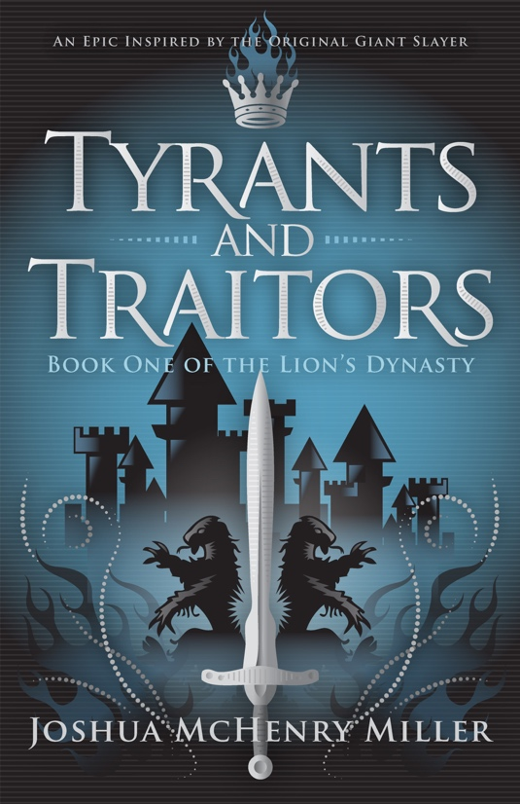
Title: Tyrants and Traitors

ISBN: 978-0996867320

Audience: Young Adult / Fantasy / Adventure

Edition: Paperback, 280 pages, $14.95
ebook, 280 pages, $4.99

Author: Joshua McHenry Miller

Publication Date: October 10, 2016

Publisher: Blue Ink Press

Distributor: Ingram (paperback); Amazon, OverDrive (ebook)

Book Description:
“Find the traitor hiding within Israel,” the seer warns Niklas, “or our nation will be enslaved and your hometown slaughtered.”
So, no pressure.
Niklas, a fifteen-year-old shepherd, spent his whole life dreaming of revolt against the hygiene-adverse Philistines, but when the all-but-impossible mission is thrust upon him, he starts to rethink the whole hero business. What chance does the daring schemer have when lions, the Mad King, and a literal giant stand in his way?
As Niklas races to uncover the hidden traitor, conspiracies and armies converge on the nation—with his hometown directly in the crossfire.

Author Information

Author Name: Joshua McHenry Miller

Email: JoshuaMcHenryMiller@gmail.com

Website: http://joshuamchenrymiller.com

Author Bio:

Joshua McHenry Miller, a native Michigander, grew up living in two worlds: the cozy suburbs of Detroit and the urban jungle of Pontiac. A lover of story in all forms, he’s spent over a decade honing his writing, and Tyrants and Traitors, is his debut novel. When Josh isn’t writing, he works as a community developer in south-central Madison, Wisconsin.

Author Events: To schedule author readings, signings, writing workshops, school visits, or other author events, please contact Amanda Gawthorpe of Blue Ink Press via email at Amanda@blueinkpress.com or by phone at (919) 264-2062.

